Applecross Senior High School

Western Australian Certificate of Education
Semester One Examination, 2018

Question/Answer Booklet
MATHEMATICS

____
98
METHODS
UNIT 1

Section Two:
Calculator- assumed Score for this booklet

Student’s Name: _______________________________________
As shown on your exam timetable.

Student’s Teacher Mr Bradbury Mr Nesa
(Circle your teacher’s name.)
Ms Thamrin

Time allowed for this section
Reading time before commencing work: ten minutes
Working time for this section: one hundred minutes

Materials required/recommended for this section
To be provided by the supervisor
This question /Answer Booklet
Formula Sheet (retained from Section One)

To be provided by the candidate
Standard Items: pens (blue/black preferred), pencils (including coloured), sharpener,
correction fluid/tape, eraser, ruler, highlighters.
Special items: drawing instruments, templates, notes on two unfolded sheets of A4 paper,
and up to three calculators approved for use in the WACE examinations.

Important note to candidates
No other items may be taken into the examination room. It is your responsibility to ensure
that you do not have any unauthorized notes or other items of a non-personal nature in the
examination room. If you have any unauthorized material with you, hand it to the supervisor
before reading any further.

Section | Number of questions available | Number of questions to be answered |  | Working time (minutes) | Marks available | Percentage of exam
Section One:  Calculator-free | 8 | 8 |  | 50 | 52 | 35
Section Two:  Calculator-assumed | 13 | 13 |  | 100 | 98 | 65
 |  |  | Total |  | 150 | 100

Instructions to candidates

- The rules for the conduct of examinations are detailed in the School Examination Rules provided with your exam timetable. Sitting this examination implies that you agree to abide by these rules.

- Write your answers in this Question/Answer Booklet.

- You must be careful to confine your responses to the specific questions asked and to follow any instructions that are specific to a particular question.

- Spare pages are included at the end of this booklet. They can be used for planning your responses and/or as additional space if required to continue an answer.
- Planning: If you use the spare pages for planning, indicate this clearly at the top of the page.
- Continuing an answer: If you need to use the space to continue an answer, indicate in the original answer space where the answer is continued, i.e. give the page number. Fill in the number of the question(s) that you are continuing to answer at the top of the page.

- Show all your working clearly. Your working should be in sufficient detail to allow your answers to be checked readily and for marks to be awarded for reasoning. Incorrect answers given without supporting reasoning cannot be allocated any marks. For any question or part question worth more than two marks, valid working or justification is required to receive full marks. If you repeat an answer to any question, ensure that you cancel the answer you do not wish to have marked.

- It is recommended that you do not use pencil, except in diagrams.

- The formula sheet and your notes are not to be handed in with your Question/Answer Booklet.

Section Two: Calculator-assumed 65% (98 Marks)
This section has thirteen (13) questions. Answer all questions. Write your answers in the spaces provided.

Working time: 100 minutes.

Question 9 (4 marks)
The graphs of $y=2x^{2}+2x+c$, $y=a{\left(x-2\right)}^{2}+1$ and $y=(x+b)(x+3)$ are shown below.

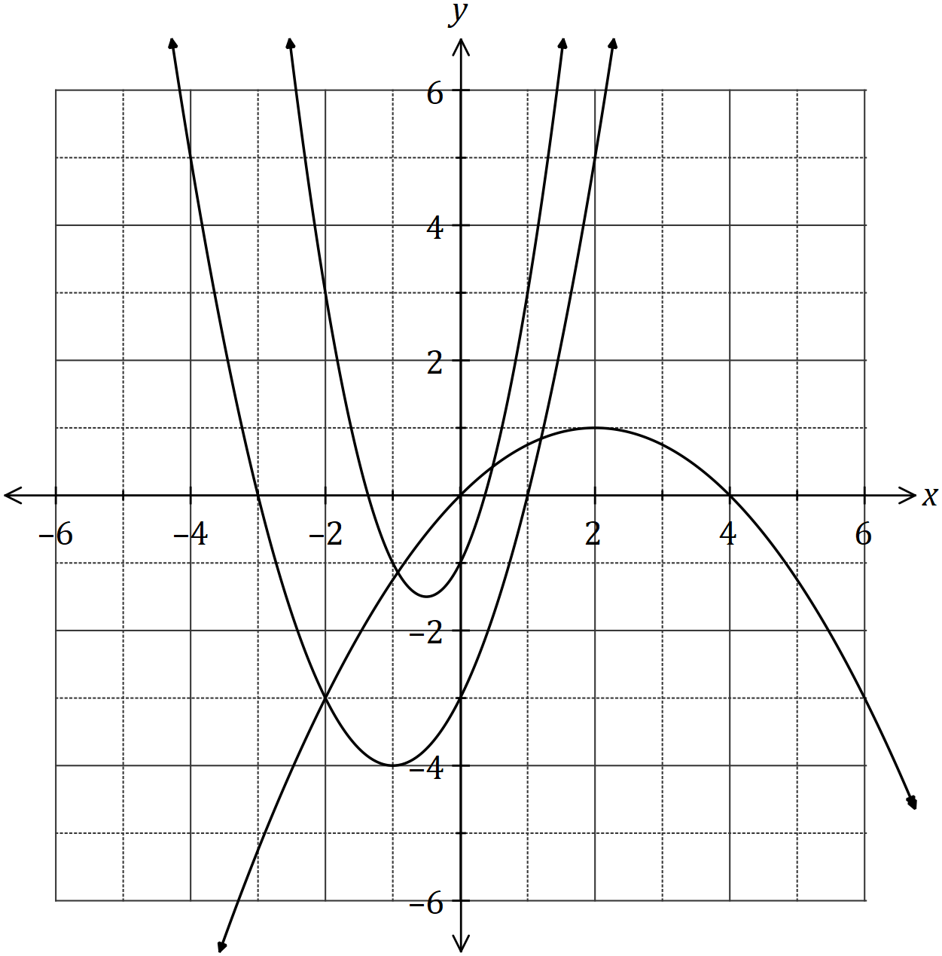

Determine the values of the constants $a, b$ and $c$.

Question 10 (7 marks)
(a) The graph of a relationship is circular, as shown below.

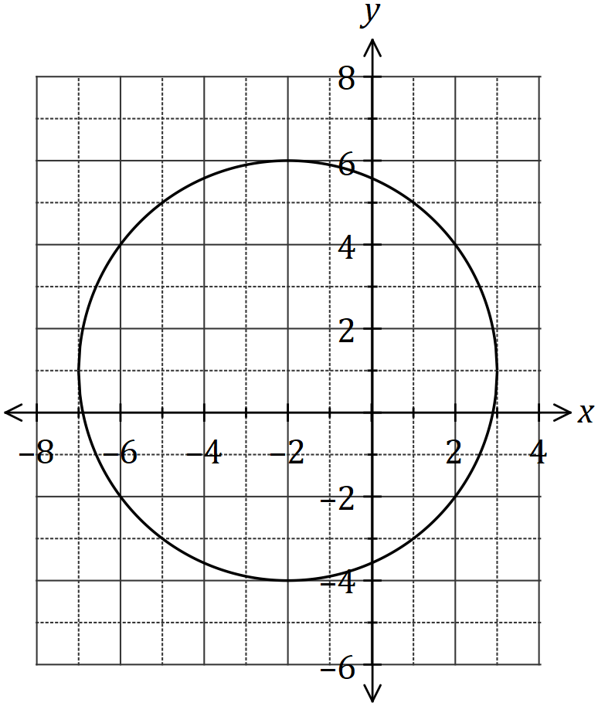

Determine the equation of this circle in the form $x^{2}+y^{2}=a+bx+cy$,
where $a, b$ and $c$ are constants. (4 marks)

(b) The line $x+y+1=0$ intersects the circle at the points $A$ and $B$. Show that the line passes through the centre of the circle, and hence determine the distance $AB$. (3 marks)

Question 11 (6 marks)
A thin pole stands vertically in the middle of a level playing ground. From point $A$ on the ground, the angle of elevation to the top of the pole, $T$, is 18º.

From point $B$, also on the ground but 5.35 metres further from the foot of the pole than $A$, the angle of elevation to the top of the pole is 15º.

(a) Draw a sketch to represent this information. (1 mark)

(b) Showing use of trigonometry, determine the height of the pole. (5 marks)

Question 12 (7 marks)
Let $f\left(x\right)=\begin{matrix}4 \\ \overline{3-x}\end{matrix}$ and $g\left(x\right)=\begin{matrix}1 \\ \overline{x+p}\end{matrix}+q$, where $p$ and $q$ are constants.

The graph of $y=g(x)$ is shown below.

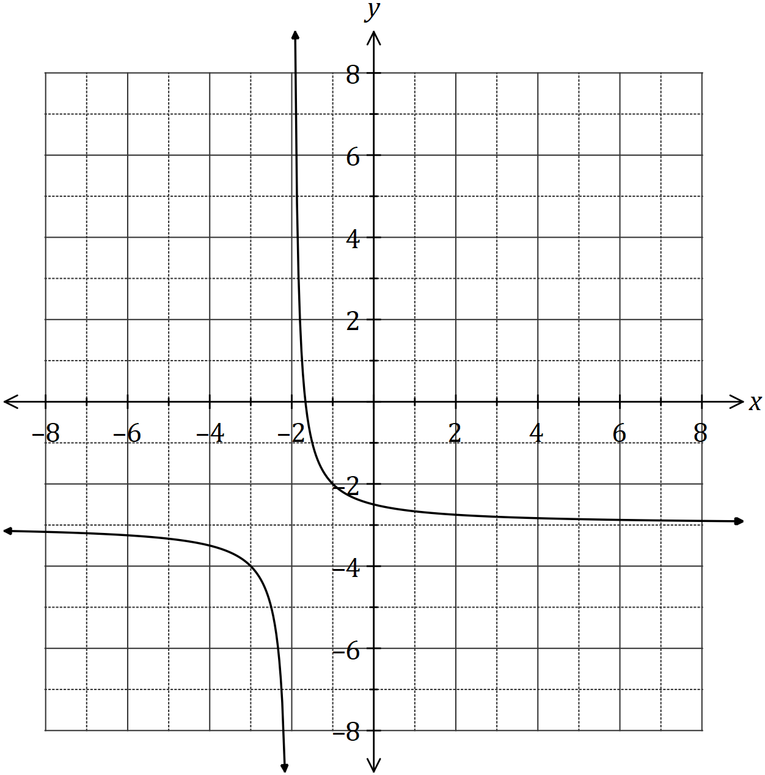

(a) Sketch the graph of $y=f(x)$ on the axes above. (3 marks)

(b) Determine the values of $p$ and $q$. (2 marks)

(c) Solve the equation $f\left(x\right)=g(x)$, giving your solution(s) to one decimal place. (2 marks)

Question 13 (6 marks)
(a) Determine the equation of the axis of symmetry for the graph of $y=3x^{2}+12x+40$.
(2 marks)

(b) The graph of $y=ax^{2}+bx+13$ passes through the points $(-3,-23)$ and $(4, 5)$. Determine the values of the constants $a$ and $b$. (4 marks)

Question 14 (10 marks)
A logo with triangular outline $ABC$ contains a shaded segment bounded by the straight line $PM$ and the circular arc $PM$ with centre $B$ and radius $BM=18$ cm, as shown below.

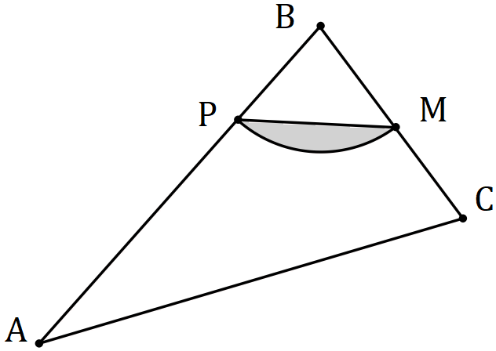

Given that $∠ABC=\begin{matrix}5π \\ \overline{12}\end{matrix}$, $∠BCA=2∠BAC$ and $M$ is the midpoint of $BC$, determine

(a) the size of $∠ABC$ in degrees. (1 mark)

(b) the area of the shaded segment. (2 marks)

(c) the perimeter of the shaded segment. (3 marks)

(d) the area of triangle $ABC$. (4 marks)

Question 15 (9 marks)
(a) The graphs of the following, where $a, b, c, d, e$ and $f$ are constants, are shown below.

$$y=\sin\left(ax\right) y=b\cos{(x)} y=\tan{(cx)} y=d\sin\left(x\right) y=\cos\left(ex\right) y=f\tan{(x)}$$

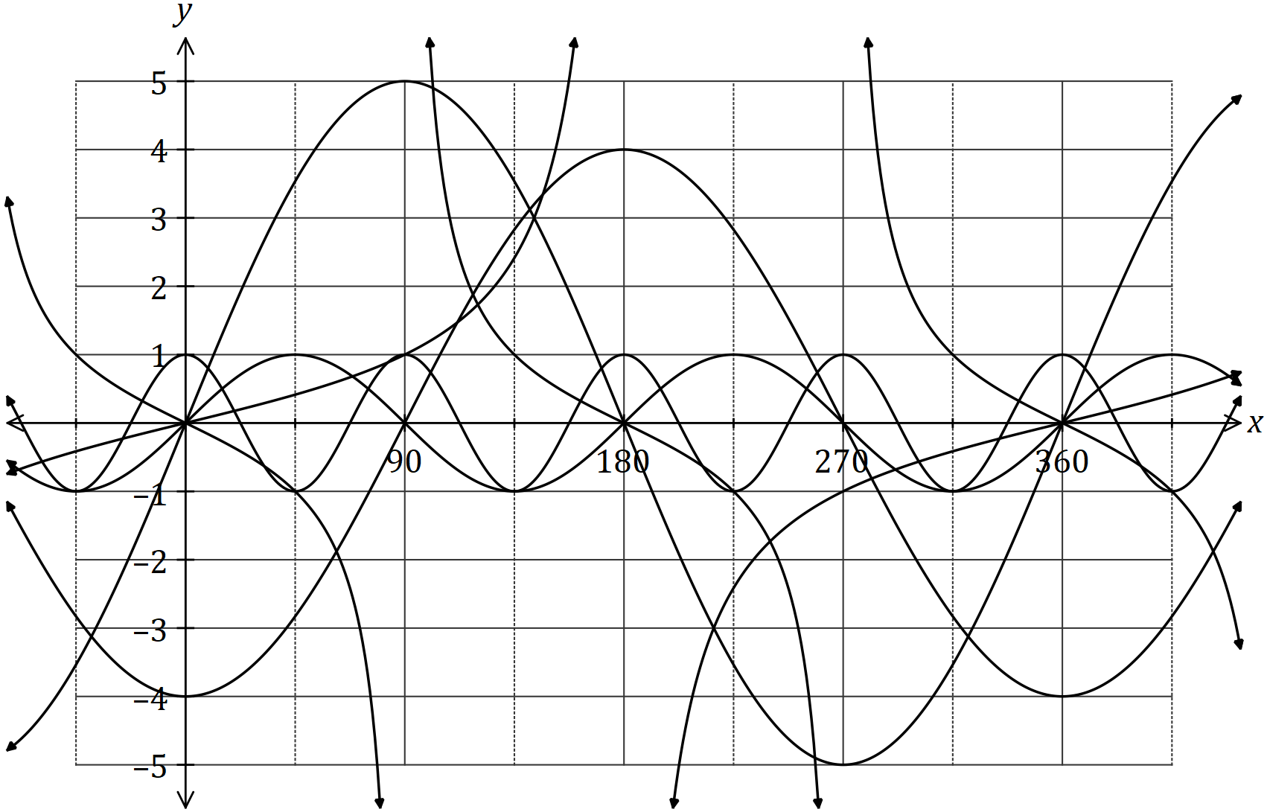

State the values of $a, b, c, d, e$ and $f$. (6 marks)

Constant | Value
$$a$$
$$b$$
$$c$$
$$d$$
$$e$$
$$f$$

(b) Calculate the acute angle in degrees between the lines $y=x+5$ and $y=3x-1$,
rounding your answer to one decimal place. (3 marks)

Question 16 (6 marks)
(a) The graph of $y=f\left(x\right)$ is shown in bold below. The graphs of $y=-f\left(x\right), y=f(x+p)$ and $y=f\left(x\right)+q$ are also shown, where $p$ and $q$ are constants.

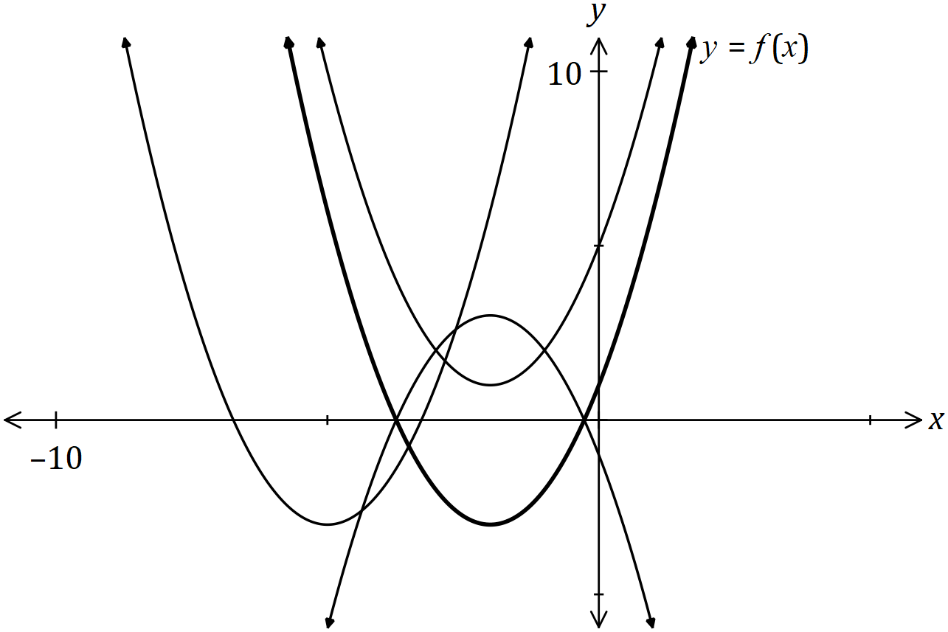

Clearly label the remaining graphs with $y=-f\left(x\right), y=f(x+p)$ or $y=f\left(x\right)+q$.
(3 marks)

(b) The one-to-one relation $y=7-3x$ has domain and range given by $\{x:x=-2, 3, a\}$ and $\{y:y=-8,-2, b\}$ respectively. Determine the values of constants $a$ and $b$. (3 marks)

Question 17 (9 marks)
The wind speed at a weather station, $v$ metres per second, $t$ hours after recording began, can be modelled by the function

$$v=20-5.8t+0.75t^{2}-0.02t^{3}, 0≤t≤24$$

(a) Calculate the wind speed when $t=11$. (1 mark)

(b) Sketch the graph of wind speed against time on the axes below. (4 marks)

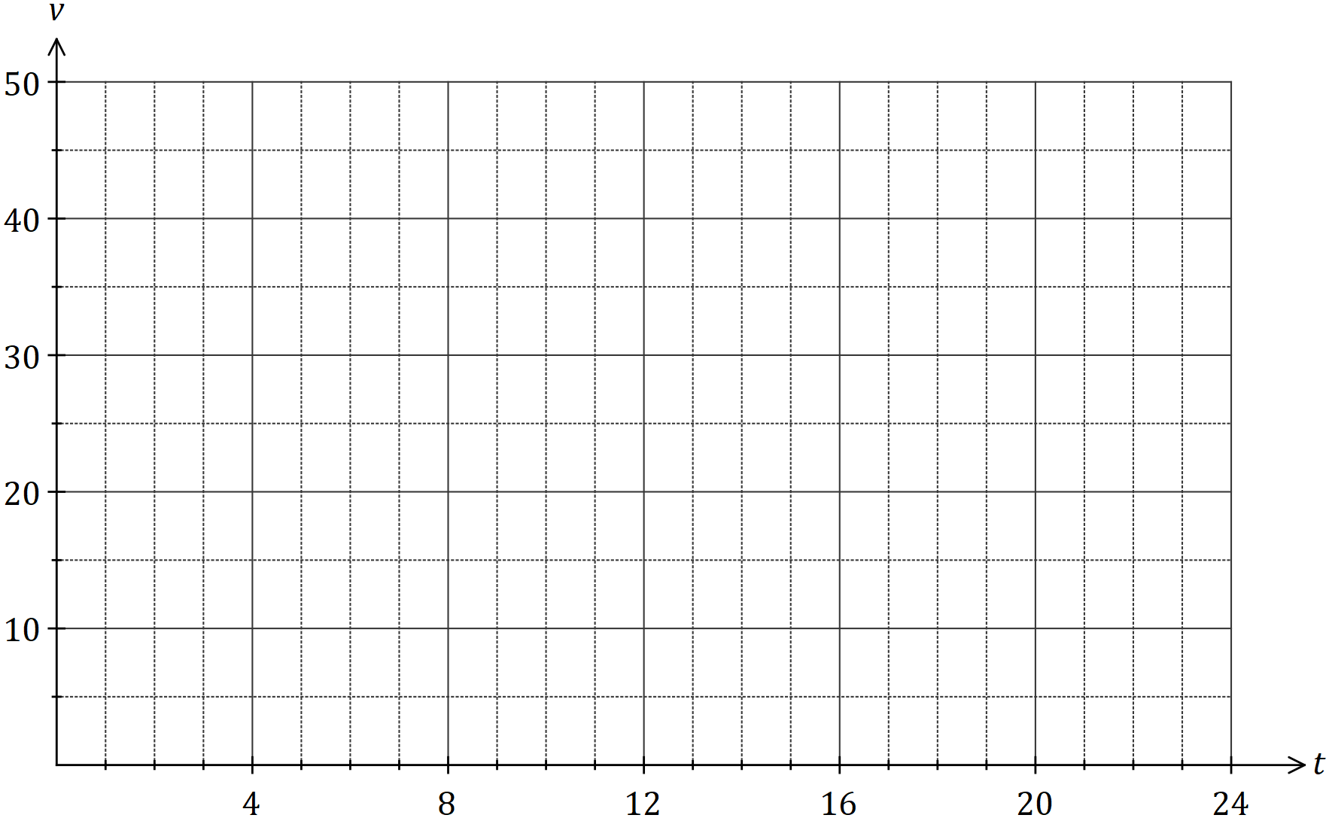

(c) During the 24-hour period, determine

(i) the time at which the wind speed was greatest. (1 mark)

(ii) the minimum wind speed. (1 mark)

(iii) the length of time, in hours and minutes, that the wind speed was increasing.
(2 marks)

Question 18 (6 marks)
(a) Part of the graph of $y=f(x)$ is shown below, where $f\left(x\right)=-2{\left(x-b\right)}^{3}+c$, and $b$ and $c$ are constants.

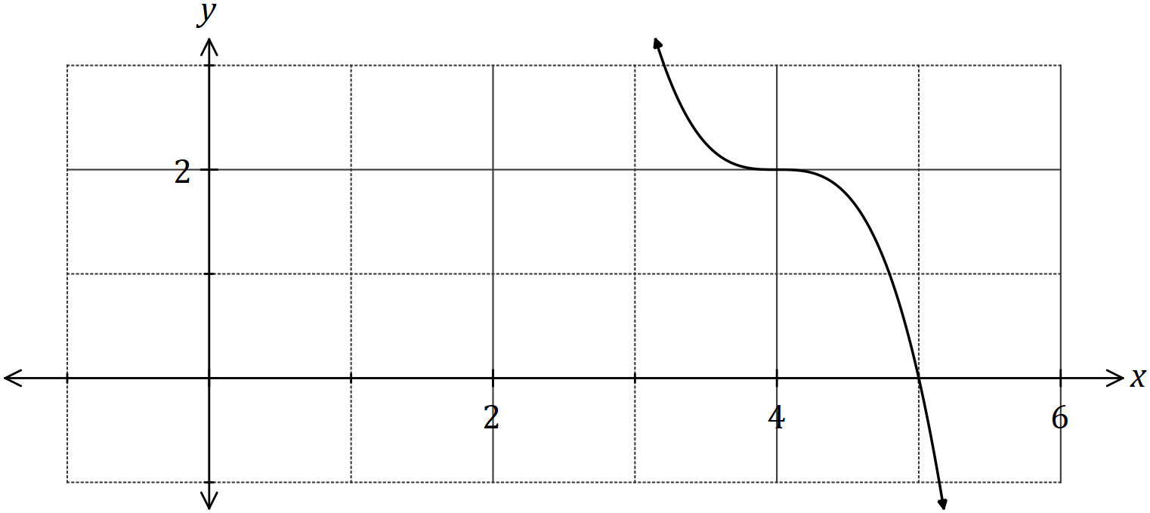

(i) State the degree of $f(x)$. (1 mark)

(ii) Determine the value of $b$. (1 mark)

(iii) Determine $f(0)$. (2 marks)

(b) Another function is given by $g\left(x\right)=f(x+8)$.

Describe how to obtain the graph of $y=g(x)$ from the graph of $y=f(x)$. (2 marks)

Question 19 (13 marks)

(a) The cross-section of a wooden hand rail is formed by the intersection of two quadratic functions shown below. The upper curve is modelled by the equation 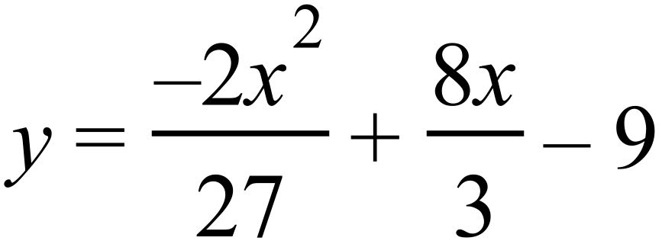 .
The equation of the lower curve is a quadratic of the form 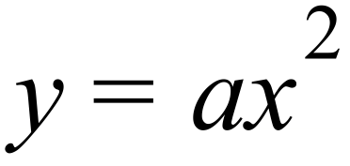 .
The two curves meet at 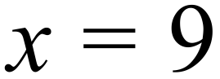 .
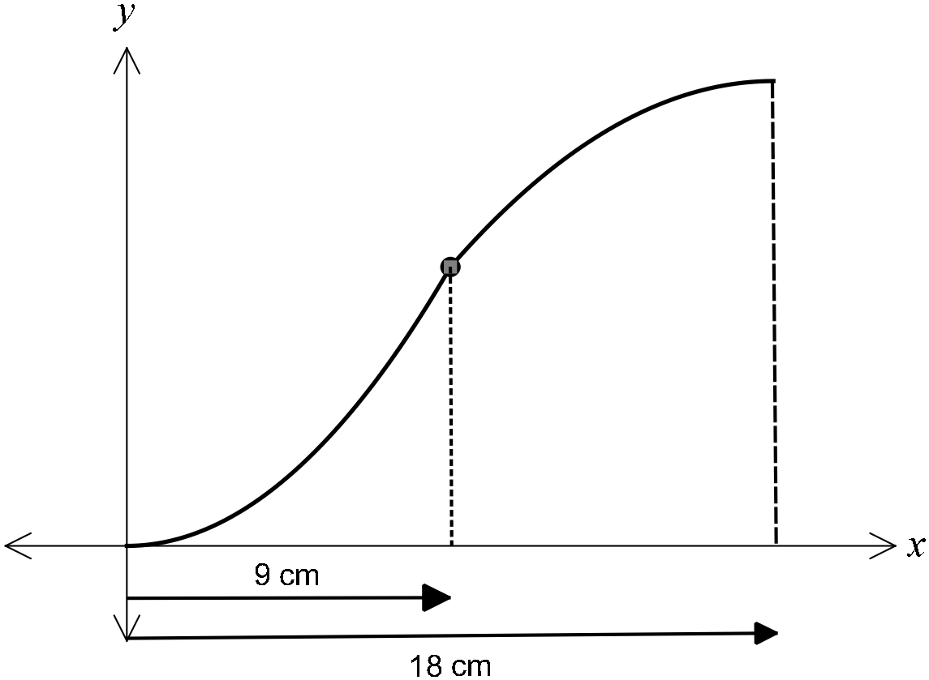

(i) Determine the coordinates of the point where the two curves meet. (1 marks)

(ii) Determine and hence state the equation of the lower curve (2 marks)

(iii) If the hand rail was moved up 3 cm, determine the new equations of the upper
and lower curves. (1 marks)

(b) Determine the equation

(i) of the line passing through the point 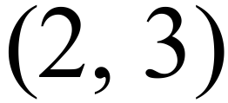 and parallel to the line with
equation 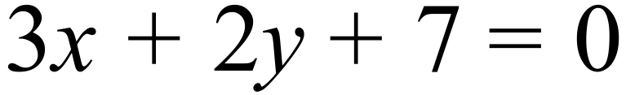 (2 marks)

(ii) of the line which is the reflection of the line 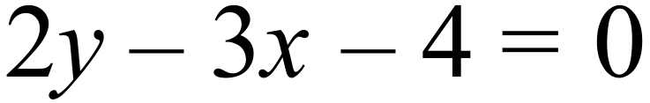 in the y-axis (2 marks)

(c) Consider a rope fixed at B and tightly wrapped around a disc A as shown in the diagram below.

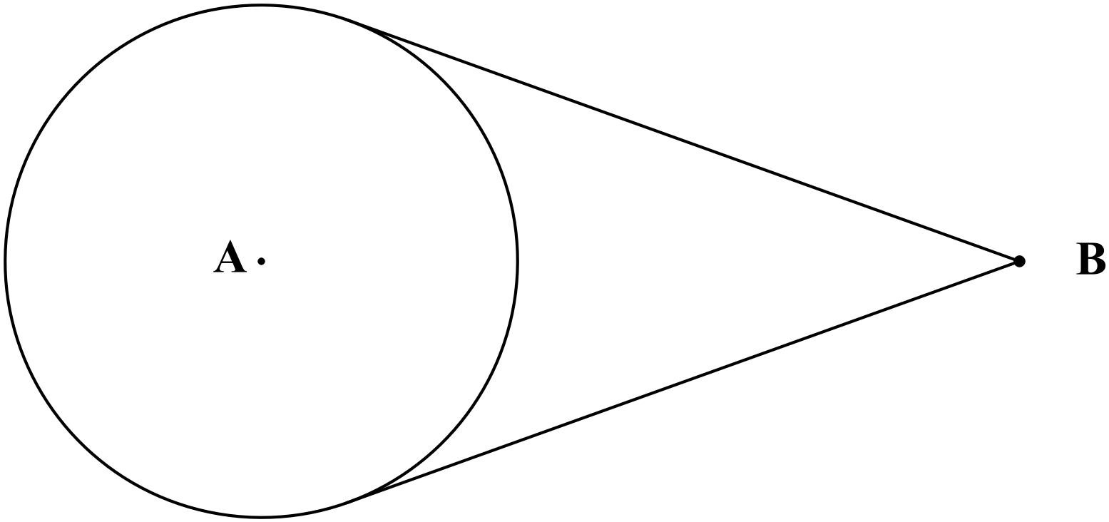
Given that disc A has a radius of 10 cm and the distance of B from the nearest edge of
disc A is twice the radius of disc A, determine the length of the rope. (5 marks)

Question 20 (7 marks)
Consider the points with coordinates $(p, q)$ and $(r, s)$ that lie in the first and second quadrants respectively of the unit circles shown below, where $θ$ and $γ$ are acute angles.

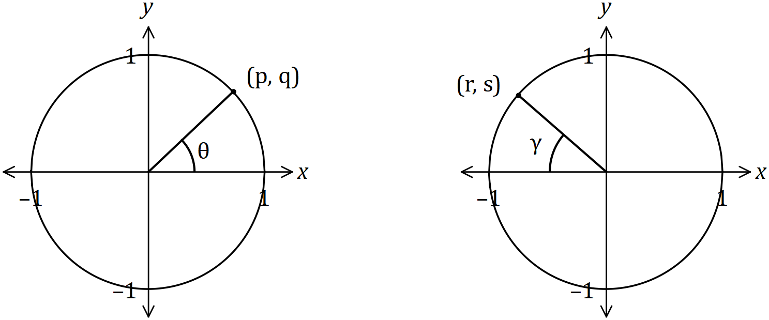

Determine the following in terms of $p, q, r$ and $s$, simplifying your answers where possible.

(a) $\tan{θ}$. (1 mark)

(b) $\sin{(180°-θ)}$. (1 mark)

(c) $cos⁡γ$. (2 marks)

(d) $\sin{(π+γ)}$. (1 mark)

(e) $tan(-γ)$. (2 marks)

Question 21 (8 marks)
(a) For a given set of numbers the set of points is defined as follows:

- State the Domain of (1 mark)

- State the Range of . (2 marks)

(b) If the set is redefined as follows:

- List the elements of (2 mark)

- State the Range of. (1 marks)

(c) Comment on whether either of would qualify to be called a function?
Justify your comment. (2 marks)

Additional working space.

Question Number:_________

Additional working space.

Question Number: _________

Additional working space.

Question Number: _________

